|  |  |
| --- | --- |
| Program: | CPA3 |
| Course: | INFO3111 – C++ Graphics – Summer 2023 |
| Professors: | Michael Feeney |
| Project # 2: | Basic 3D scene with basic 2D textures applied |
| Weight: | 15% of your final mark |
| Due Date: | Sunday, June 18th @11:59 PM (“midnight)  (Note: This is due after the final exam) |

Description and Purpose

Make your project #1 submission even more beautiful using textures and transparency.

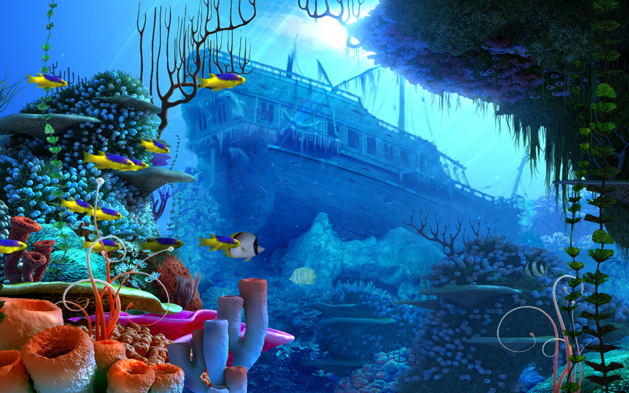

**You are going to make an underwater scene involving a shipwreck, rocks, fish, etc.**

The usual warnings:

* Any “debug” items (like the wireframe spheres used to place the lights) should be **off** by default (when the application is started).
* Bind the number keys to switch between camera locations (if needed).
* Unless it’s obvious, CLEARLY indicate which questions you are answering.   
  For example: “Press number key 2 to see the answer to questions 1 and 2”
* You can also make a “readme” file that is SEPARATE from the solution.   
  i.e. I will *NOT* try and hunt down comments buried in the source code.   
  (If your “readme” directs me to certain parts of the code, that is likely OK)
* I will *NOT* change your code. I should run AS IS.   
    
  Do NOT indicate something like “Comment out lines X to Y to see question 3” or something like that.   
  I will NOT read stuff like that.

**If it doesn’t run, I will assume it can’t run, and you will get a mark of zero.**

**It MUST build and run in RELEASE mode (64 bits).**

(I *might* do something minor like try to unzip the libraries files that github stripped out or something along those lines, but I should be able to download it, build it, and run it, without incident.)

Warning level 3 is fine. In fact, I’ll almost certainly completely ignore any “warnings”.

**No “boost” library or “auto” keyword. Use of these will give you a mark of zero, no exceptions.**

You can only use code that was provided for you during course, or that *you* wrote during this course.

Use of any other code is not allowed. This includes, but is not limited to:

* chatGPT code.
* Code you “borrowed” from some other site.
* Some game engine.
* Etc.

Here’s the thing: I know the code *\*I\** wrote and if I’m suspicious that you had didn’t actually write (i.e. understand) the code you submitted, I’ll simply ask you about it face-to-face. Like why you did this or that, how you might do it differently, ask how you might have changed stuff. If you just “got this code somewhere”, it’ll be pretty obvious, based on your responses.

Details:

These marks are assuming that you already have a complete scene to work with.

What I mean is that if you add textures to models that aren’t “appropriately” in the scene as per project #1, you may not get these marks. So you can’t just throw a bunch of random models on screen.

Add the following textures to these models:

* (40 marks) Add a “water” texture to the **water surface** model. This texture should show either white wave crests (like the foam sometimes on the peak of the waves) and/or water “caustics” (here’s an example of what water caustics look like: <https://media.istockphoto.com/id/1401109428/photo/swimming-pool-from-above-reflecting-water-surface-on-a-sunny-day-summer-caustics-liquid.jpg?s=612x612&w=0&k=20&c=R5nT-qr2QlRq5IPPMF02WJyUwD_xO1rM6pI_Hyt_eis=>).   
    
  Make the surface of the water semi-transparent and camera independent (we can be above or below the water and a) still see the water and b) it appears transparent and have the appropriate textures).
* (10 marks) Add a “sand” texture to the **sea floor**, specifically something like “beach sand” or “little rocks” or something that looks like it would be the sandy seafloor somewhere near the tropics.
* (10 marks) Add a “wood” texture to the **shipwreck** model (or models). This should be wood planks, not just like a solid piece of wood.
* (10 marks) Add the “whale” texture to the **whale** model.
* (15 marks) Add at least three (3) “tropical fish” textures to the **fish** or **fish clusters**. You can use these textures more than once, on different fish models, but it should be clearly visible that there are three (3) different textures present.
* (30 marks) Add an appropriate “jelly fish” texture to the three (3) **jelly fish**. What I’m looking for is something that, once applied, looks something like a jelly fish. Brightly coloured, etc.   
    
  Make the jelly fish **semi-transparent**, and make the transparency camera independent. This includes the water surface: you should be able to see semi-transparent jelly fish when looking from above the water, and when lookup “up” through one (or more) jelly fish, you should be able to see the water surface.
* (30 marks) Add at least three (3) appropriate “underwater plant” textures to the **plants**. You can use these textures more than once, but there should be clearly three (3) different textures present. Underwater plants are often green, orange, yellow, or dark brown. I’m looking for textures that are *not* terrestrial plants (like tree leaves, etc.)
* (10 marks) Add a “rock” texture to the **rocks** in the scene. This can be the same texture for all of them.

**BONUS (5% overall each):**

* (5%) Mimic the movement of the water surface by:
  + Gradually “move” the texture by slightly updating the water texture coordinates over time.
* (5%) More complicated water surface movement (this *gives you 10%* since you did the above):
  + Add a 2nd different water texture, and move both textures in different directions by updating the texture coordinates slightly over time at a different rate.
* (20%) Update the surface of the water by displacing the vertex heights:
  + 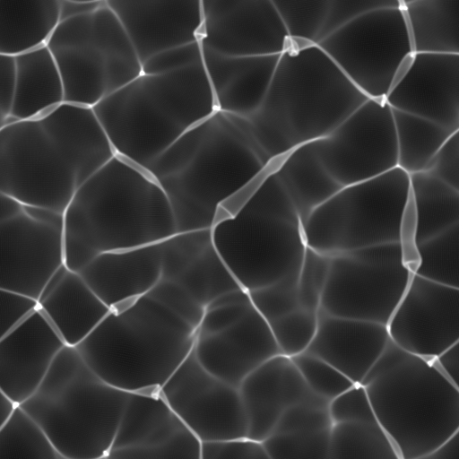Get two greyscale/black&white “water caustic texture height map” textures (i.e. google that):   
       
     Here’s an example 🡪
  + “move” these two textures the same way as the 2nd bonus (two textures being offset slightly over time, in different directions and different speeds).
  + Update the height of the water surface model based on the greyscale colour of both of these textures. This will cause the surface of the water model to change in height.
  + (+5%) Add “white caps” to the water surface by: Use the value from the previous step and change the colour of the water surface to white if the height is above some specific value. Leave the colour blue (or green, or whatever – not white though, it’s supposed to look like the water *without* the white caps).

You will submit:

* **Your entire solution** (PLEASE remove the “extra” files from it, making it smaller), and compress it.
* **A video demonstrating your application.** This can be using OBS or zoom or FRAPs or even your cell phone camera but has to *clearly* show:  
  + You launching the application from visual studio
  + CLEARLY showing some identifying information, like a comment in the code with your student name and number
  + What you are doing (buttons being pressed, etc.) as it is happening.

Additional requirements:

* While you may freely “borrow” mine (or anyone other) code ***but*** your code should be “sufficiently” different from mine in terms of the output on screen. See the "plagiarism" test, later in this document, for more details.
* Further, you *cannot* simply use an existing game engine (or part of a game engine), even if it's a "from source" engine (i.e. you have the entire source) to complete this assignment; it should be either completely new of significantly modified. This includes, but is *not* limited to: Unity, Unreal, Cry, Anarchy, XNA, Cocos, Ogre, the framework from the OpenGL text, etc.   
    
  Related to plagiarism/cheating and not doing much work:   
  + If you simply submitted the in class code, then you invested zero time, so you did no work, so you get a mark of zero (in that case, it is a clear case plagiarism/cheating, and an academic offence would also be submitted).
  + If you took the in class code and made some trivial changes - like replaced the teapot model with the rabbit model, slightly repositioned them, and maybe changed their colour - you might not have actually "cheated", but you did essentially no work: "How long would it take me - your instructor - to make those changes?" If it's something that would take 10 minutes, you won't get many parks for that
  + It has to be something that a random "typical" person would say "yes, that's significantly different" in order to "be different".
  + If you code does not even compile, I will not mark it. Since it can't run, you would get a mark of zero.
  + If you code does not build (i.e. linker error) and run (i.e. no crazy run-time crash that is unexpected), I may investigate this further, but only if there is some simple problem and/or *very* slight and/or *very* obvious (and easy to fix) configuration error or last minute typo.
  + **\*\***You can **\*not\*** submit something just clearly based on the mid-term (*including the mid-term itself*).

Project Corrections

If any corrections or changes are necessary they will be posted to the course web site and you will be notified of any changes in class. It is your responsibility to check the site periodically for changes to the project. Additional resources relating to the project may also be posted.

80/8-year old “squinty eye” plagiarism test:

I have very little tolerance for plagiarism, but some students might be unclear about what it is.

Basically, it’s submitting somebody else’s work as your own.

There is sometimes some confusion over this because you could argue nothing is actually “unique” (see: <http://everythingisaremix.info/> for a fascinating overview of this).

The whole point of assignments/tests/projects in this course (or any course, really) is to try to see if you are actually able to ***do*** the coding that’s asked of you. In other words: How competent are you? Handing me someone else’s code and/or making a trivial change isn’t good enough.

Also, it’s illegal:

* <http://www.plagiarism.org/ask-the-experts/faq/>
* <http://definitions.uslegal.com/p/plagiarism/>
* <http://en.wikipedia.org/wiki/Plagiarism>
* <https://www.legalzoom.com/articles/plagiarism-what-is-it-exactly>

In other words, I’m not going to be drawn into a giant debate over how “different” your code is from mine or anyone else’s, if any sensible person (including me) would conclude that the code/application is pretty much the same thing, then it is. It is up to my discretion to decide this.

* While you may freely “borrow” mine (or anyone other) code ***but*** your code should be “sufficiently” different from mine (you might want to replace the word “sufficiently” with “significantly”).
* In other words, you *cannot* simply use an existing game engine (or part of a game engine) to complete this assignment; it should be either completely new of **significantly** modified.
* How will I determine this?
  + If I showed your application and/or your source code to either a pragmatic 80-year-old mother, or a typical 8-year-old, or even some random person walking down the hallway (i.e. a non-expert), and they looked at it, tilted their heads, squinted their eyes, and said “you know, they look the same,” then they ***are*** the same.
  + Another test would: How much time it would take for a "competent programmer" (me, for example) to make the changes you are submitting? The point here is that I don’t “care” if you tell me “But it took me *weeks* to make the changes!” Fine, but if I can make those same changes in 10 minutes, then not a lot of work has been done (certainly **not** sufficient work for someone who is trying to convince me they are proficient).